**How to Create a React App:**

1. Go into the folder that you need to work in and Launch the command prompt. Then write the following command prompts

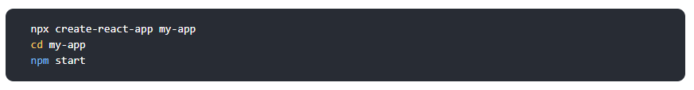

|  |
| --- |
| npx create-react-app my_first_app  **How to run the server**  cd my_first_app  npm start |